

**Artificial Intelligence and Data Science Department.**

OOPM / Odd Sem 2021-22 / Experiment.

YASH SARANG.

47 / D6AD.

EXPERIMENT - 8.

**____________________________________________________________**

**AIM:** To write a program to demonstrate use of final variable.

**____________________________________________________________**

**Program 1:**

import java.util.*;

final class ship

{

public static void main(String args[])

{

final int var = 32;

System.out.println("Value of var is " + var);

var = 100; //ERROR

System.out.println("Value of var is " + var);

}

}

**The output of program 1:**

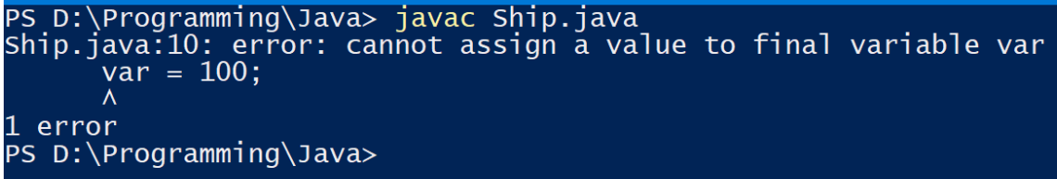

**____________________________________________________________**

**THEORY + CONCLUSION :** 

